**Interview Protocol: Michigan Flower Growers’ Cooperation**

**Overarching Research Question**

What are florists’ and growers’ experiences with the pre-order process and what would improve the process from both perspectives?

**Interview Questions**

Interviewer instructions are written in red.

**I. General Information and Warm-up**

Note: This is to get background information on the user and give them time to warm up to the process as well as to you. These should be light and simple.

Tell me a bit about how you got into the business.

What’s your favorite part about being a florist/flower distributor?

**II. The Process of Flower Buying (florists only)**

Note: This is to help understand the flower buying process as well as the best and worst parts of it. Probes are listed but this section will necessarily warrant more probes depending on answers to the initial questions. Try to go as deep as possible here. Some of these will start to seem repetitious but each question is aimed at a different part of the process.

Tell me about the last time you ordered flowers through the co-op. Can you walk me through that process?

* What are the steps?
* What interface did you use--mobile vs desktop
* What barriers did you run into?
  + Why was this barrier important?
* What was the best part of this?
  + What made this part stand out to you?

What is most important to you in the process of finding, buying, and acquiring flowers?

* Why is that important to you?
* Note: This will require further probing based on the answers.

What has been your best experience buying flowers?

* Why was it the best?
* Note: Continue to probe based on the answer.

**III. The Process of Flower Selling (growers only)**

Tell me about the last time you sold flowers through the co-op. Can you walk me through that process?

* What are the steps?
* What interface did you use--mobile vs desktop
* What barriers did you run into?
  + Why was this barrier important?
* What was the best part of this?
  + What made this part stand out to you?
* (if they only mention the market and not the pre-order system) What are the steps for you to receive pre-orders?

What is most important to you in the process of growing, harvesting, and selling flowers?

* Why is that important to you?
* Note: This will require further probing based on the answers.

What has been your best experience selling flowers?

* Why was it the best?
* Note: Continue to probe based on the answer.

Can you tell us about other platforms or channels you’ve used to sell flowers in the past?

* What was that process like?
* What did you like about it?
* What did you dislike about it?
* Note: Continue to probe based on answers.

**IV. Daily activities and timeline**

Note: This section is aimed at understanding where flower buying occurs in the daily timeline of florists/floral distributors.

How often do you buy/sell flowers?

* Why?
* Ideally, how often would you want to buy flowers?

How long does the process of pre-ordering/marketing flowers take?

* Is this ideal?

In a typical week, when would the flower pre-order process occur?

Note: Only ask the following if they have not yet been answered during previous questions.

Where do you typically buy/sell your flowers?

How often do you use the MFGC pre-order process?

* Why might you use that as opposed to just buying at the market?
* Tell me more about what that process is like.
* What aspects of the process do you enjoy?
* What aspects of the process do you find difficult?

Have you used pre-order processes other than the co-op’s before?

* If yes:
  + Tell me more about that process.
  + Do you still use pre-order?
  + If yes:
    - Why?
  + If no:
    - Why not?
* If no:
* Why?

**IV. Ideal World**

Note: This is meant to give the participant a chance to elaborate on ideal processes of buying flowers. This should elicit some creativity from the participants.

If you had a magic wand, what would you change about the process of pre-ordering flowers from the co-op?

* Why?
* Continue to probe based on answers.

**V. Conclusion**

Thank you so much for your time! That’s all the questions I have for you.

Is there anything else you think I should know?

**Participatory Design Script**

**Overarching Question**

What are florists’ and growers’ experiences with the pre-order process and how do these experiences overlap and differ?

**Roles**

Facilitator - Jill

Photo/Videographer - Corbet

Notetaker 1 - Amanda

Notetaker 2 - Elisabeth

**Supplies Needed**

* Sticky notes (lots!)
* Sharpies/markers
* Pens
* Paper
* Tape
* Glue
* Any sort of crafting material we can get our hands on

**Activities**

* **Empathy Collage:** This activity will help us better understand what you say, think, do, and feel in the preorder process. We will draw a piece of paper with quadrants that looks something like this:

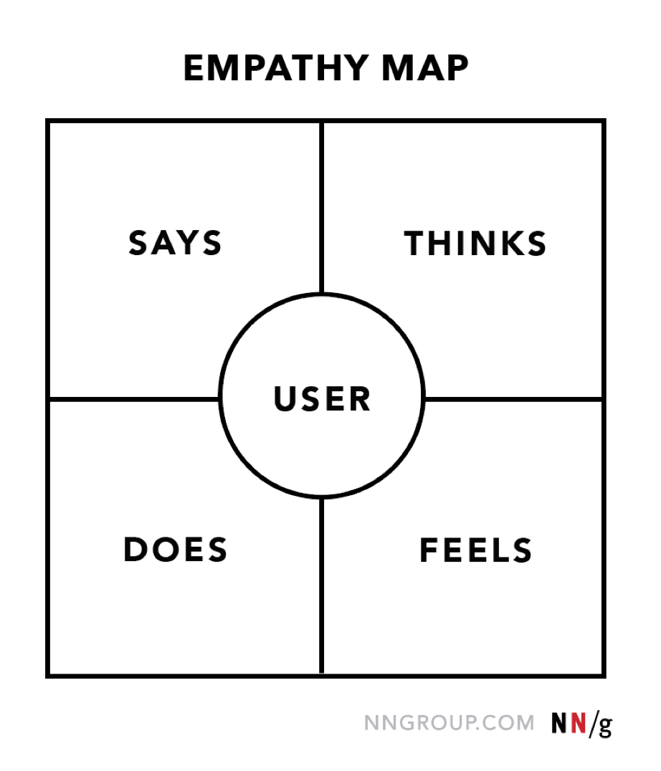

* **Journey Mapping:** We will have growers and florists walk through their week (in terms of pre-ordering/marketing) individually and then come together to understand overlaps or differences between processes. Have them fill both the steps and actions, questions, etc. in a chart that looks like the image below. Link to resource: <https://itk.mitre.org/journey-mapping/>.

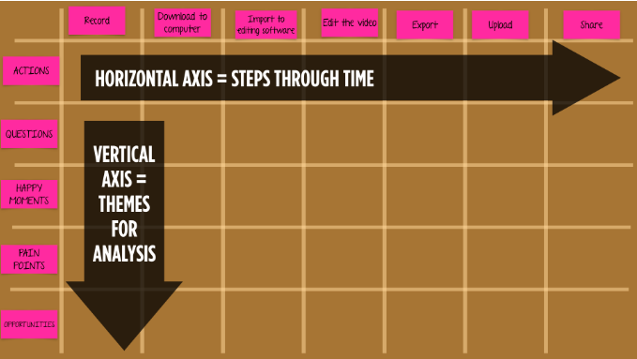

* **Crafting:** Hands on crafting to visualize fixing one part of the process outlined in the journey mapping activity.

**Script for Facilitator**

Instructions for the facilitator(s) are written in red.

**Introduction** (5-10 minutes)

Note: This section is to help introduce the participatory design workshop and what to expect to participants. Plan to split participants into smaller groups of 2-3 before coming together as a whole.

* (Ask individually to eliminate peer pressure.) Before we begin, are you okay if this session is audio recorded? The recordings will only be used for the purpose of our research.
* Thank you for participating in this participatory design workshop. The session today will take about an hour. I will be moderating this session and guiding you through several design activities. My partner(s) _____ will be taking notes. We are interested in your experiences with the pre-ordering process with the Michigan Flower Growers’ Cooperative.
* If you have any questions feel free to stop me. Do you have any questions before we begin?

**Empathy Collage (5-10 minutes)**

Note: Put blank empathy collage paper in the middle of the table

Our first activity is called an empathy collage. On this piece of paper, you will see 4 quadrants. This activity will help us better understand what you say, think, do, and feel in the preorder process. In each of the quadrants, place sticky notes with words or phrases describing each of the prompts. Are there any questions before we begin? Great, we will do this for about 10 minutes.

**Journey Mapping (15-20 minutes)**

Next, we are going to do a journey map. This will help us understand what you go through on the average week when you are going through the preorder process.

* First, each of you will individually write down on sticky notes the steps that you take. For growers, this will include the steps you go through to fill out the sheet with your inventory, and for florists, this will include what you go through to place your pre-orders.
* Also write down things such as pain points, questions, happy moments, and opportunities. Everyone take about 5 minutes to do this.

Note: Put blank journey map paper in the middle of the table.

Now, we are going to combine all of your journeys together in one map. Start by, together, figuring out the order of the steps in the process on the horizontal axis. For each step in the process, put your other observations along the vertical axis. Feel free to add anything additional as you collaborate with each other for this activity. We will do this for about 15 minutes

**Crafting (15-20 minutes)**

For our final activity, we are going to have you craft. Using the materials we have, craft something that you think would be a solution to a problem or pain point that you currently see in the preorder process. Get creative! We will do this for about 15 minutes. At the end, we will have each grower partner with a florist to share what they came up with. Then, each pair will share with everyone what they found to be similar and different about their solutions.

**Conclusion**

Thank you all so much for coming. This information will really help us give recommendations to improve the pre-order process. If you have any questions, please feel free to contact us, our contact information is on your copy of the consent form.